
AMERICAN INTERNATIONAL UNIVERSITY-BANGLADESH
Faculty of Science and Technology
Department of Computer Science
CSC 3215: Web Technologies

Semester: Summer 2025-26 | Group No: 03 | Section: J
Group Members:
SL. | Student ID | Name | Role | Signature
1 | 25-60789-1 | Tishad Zaman Tithi | Group Leader
2 | 22-49231-3 | Tasfia Tofail | Member
3 | 22-48104-2 | Shadman Shakeeb Oankit | Member
4 | 23-54413-3 | Kazi Junayad Rahman | Member
Project Title
EduPortal — A Simple Online Learning Portal
Short Description
EduPortal is a simple web-based learning portal that gives three types of users — an Admin, an Instructor, and a Student — one shared place to manage courses. Instructors publish and edit their own courses, students search for courses and enroll in them, and the Admin oversees the whole platform by managing instructor and student accounts. For this submission, only the frontend (HTML, CSS, and JavaScript) has been implemented; the interface is fully interactive and demonstrates the intended behaviour of the system ahead of the PHP/MySQL backend that will be added in the next phase.
Introduction
Most academic institutions rely on some form of online learning platform to organize courses and track student participation, but many existing systems are large and complex, with far more features than a small classroom setting actually needs. EduPortal is designed as a lightweight alternative: it focuses on the small set of actions each type of user genuinely needs — publishing a course, enrolling in a course, and keeping track of who is enrolled and how far along they are — without the overhead of a full learning-management system. The goal of this project is to apply the concepts covered in CSC 3215 (HTML, CSS, JavaScript, and later PHP) to build a working, role-based web application from the ground up.
Background Study
Existing e-learning platforms such as Google Classroom and Moodle already solve the problem of course management at scale, but they are built for institution-wide deployment and come with configuration and features (grading rubrics, plagiarism checks, integrations, and more) that are unnecessary for a small class project. Reviewing these platforms helped identify the small set of core actions that any course-management system needs at minimum: authentication with distinct user roles, the ability for an instructor to publish a course, and the ability for a student to discover and enroll in one. EduPortal is scoped around exactly this core, which keeps the system easy to build, easy to explain, and easy to extend in later phases of the course.
Use Case Diagram
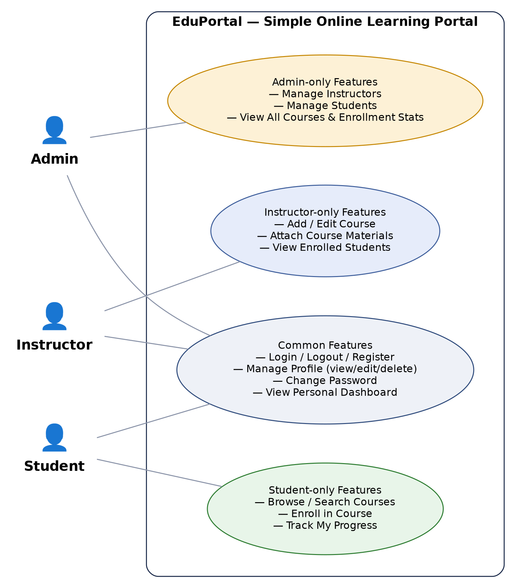
Figure 1: Use case diagram showing the three actors (Admin, Instructor, Student), their shared features, and their role-specific features.
UI (Figma/Sketch)
Since the frontend has already been implemented, the screens below are taken directly from the working prototype rather than a separate mockup tool — this is the actual tentative design of the system.
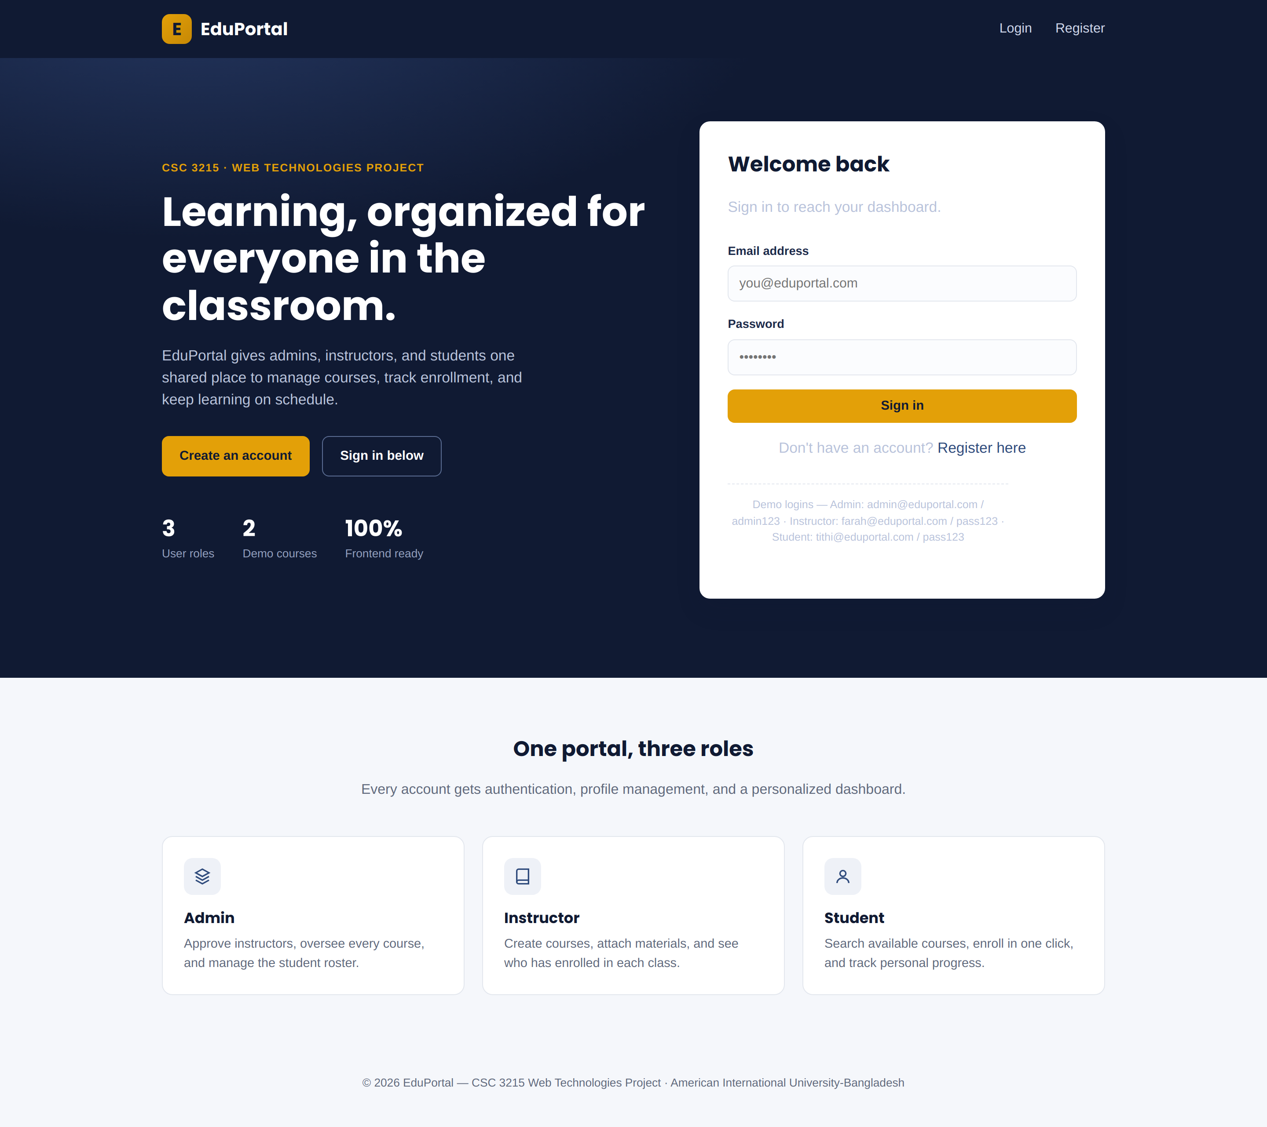
Figure 2: Landing page and login screen.
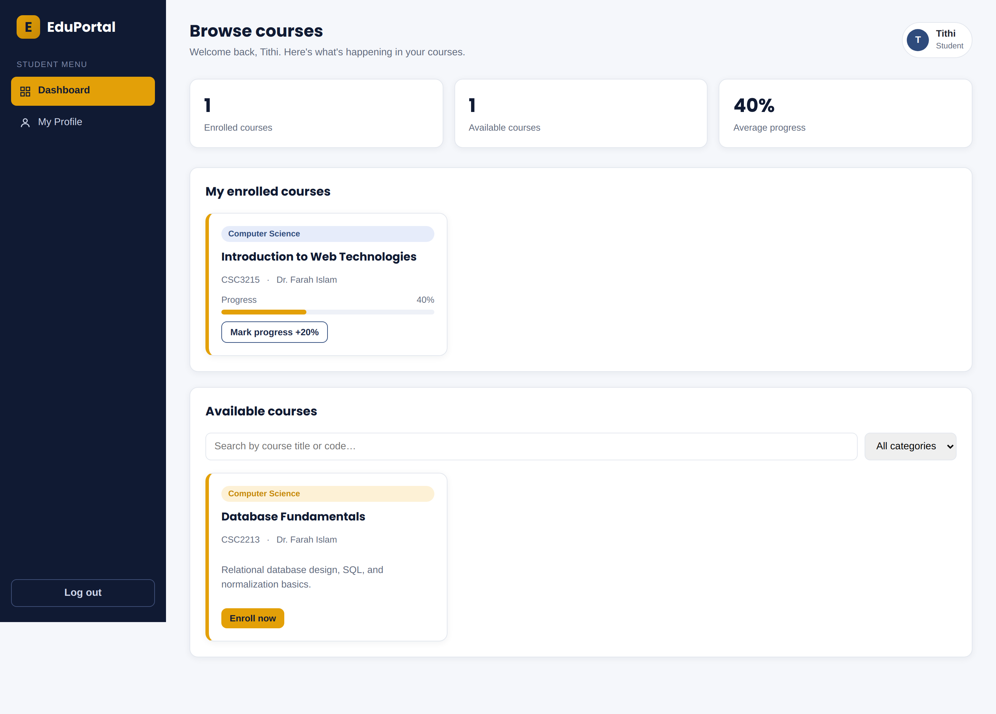
Figure 3: Student dashboard — browse and enroll in courses, track progress.
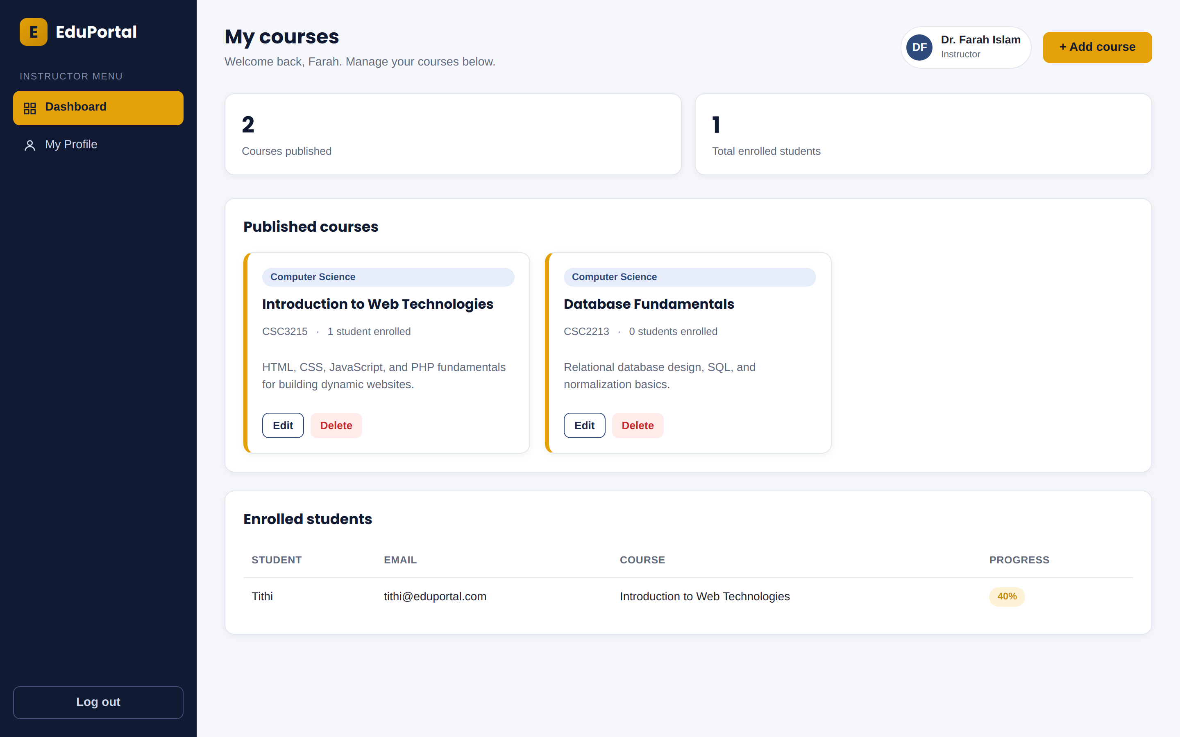
Figure 4: Instructor dashboard — manage courses and view enrolled students.
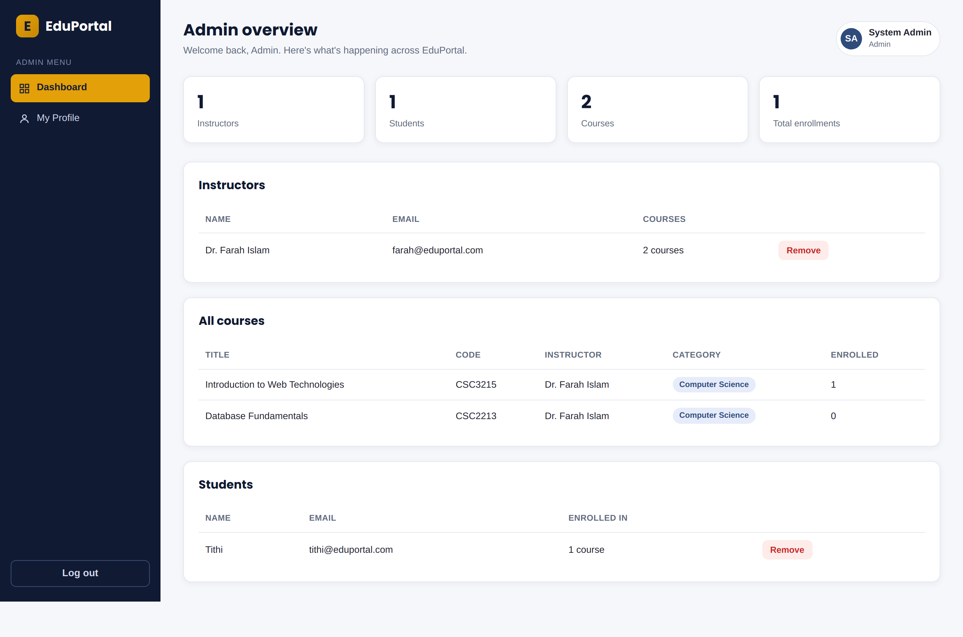
Figure 5: Admin dashboard — manage instructors, courses, and students.

Types of User: 1. Admin 2. Instructor 3. Student
Common Features (Available to All Users)
• Authentication
1. Login to the system
2. Logout from the system
3. User registration
• Account Management
1. Change or reset password
2. Manage profile information (view, edit, delete)
• Dashboard
1. Access a personalized dashboard after login
Specific Features by User Type
Features of Admin
1. Manage instructors (add, view, remove instructor accounts)
2. View all courses across the platform and see enrollment statistics
3. Manage students (view and remove student accounts)
Features of Instructor
1. Add and edit courses, including a category and description
2. Attach course materials (a link to notes/slides) to a course
3. View the list of students enrolled in each of their courses
Features of Student
1. Browse and search available courses by title, code, or category
2. Enroll in a course with a single click
3. Track personal progress in each enrolled course
N.B: Each user type has at least 3 distinct features different from the others, as required.

